Maths and STEM  You will need:  https://discoverydiaries.org/diary/mars-diary/  or  Longest Bridge PDF  Spaghetti Tower PDF | Maths and Life Skills  I can use my numeracy skills in real-life concepts e.g. 1. using money in a toy shop/green grocer etc  2. ordering and counting money to £1.  3. How much money is in my jar/purse?  Lesson on affordability might be better P3/P4  https://www.coramlifeeducation.org.uk/scarf/lesson-plans/harolds-money-1  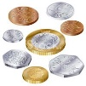  You will need:  Plastic coins  Purse  Jar  Role Play area with prices | Maths and Literacy  I can use my literacy skills to read the word problems and work out the answers.  You will need:  https://education.gov.scot/improvement/scotland-learns/resources-for-practitioners/numeracy-and-mathematics-activities/two-step-problems-and-the-four-operations-first-level/  or  Word problem sheets see in First Level file
Maths and Health and Wellbeing  I can use ml and/or L to measure how much water I drink.  You will need  How much do we drink PDF  or  Eatwell game sheet | Maths and Geography  numbers for measurement, e.g. temperatures, percentages, distances, river flows  numbers as coordinates e.g. grid references and latitude/longitude  comparative data e.g. ratios such as population density or GNP  numerical data for contextual information – e.g.to give a sense of scale and importance, for example when studying rainfall or trading patterns  quantitative data presented visually e.g. in tables, charts, graphs, maps - and we teach students the skills to interpret, analyse and evaluate this data  numbers to help us solve some geographical problems, such as finding the best location.  You will need:  Geography lesson example | Maths and History  Timelines –  Write their own timeline (example sheet)  Now and Next  Dates relating to topic etc  Research famous mathematicians  Roman Numerals or other pictorial numbers  Patterns e.g. Archimedes, Islamic Art
Maths and French  Les nombres  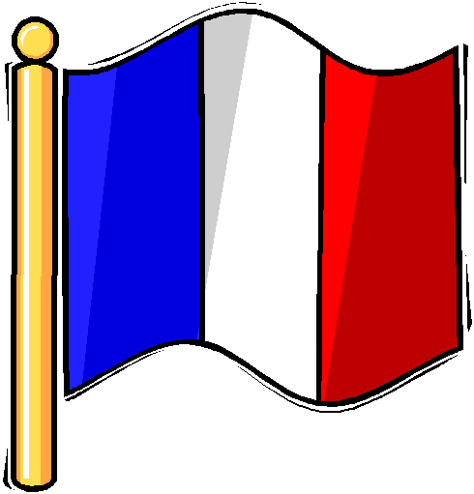  You will need:  https://www.youtube.com/watch?v=EEH0kyK0QlA  https://thirdspacelearning.com/blog/maths-in-french/ | Problem Solving  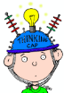  I can use a range of numeracy skills to be able to solve these problems.  You will need:  P2 hundred square jigsaw (Enrich 5572)  https://nrich.maths.org/5572  https://nrich.maths.org/93  https://nrich.maths.org/13125  https://nrich.maths.org/4332/note | Maths and the World of Work  I recognise that my maths skills play an important role in the world of work.  You will need:  https://www.stem.org.uk/resources/elibrary/resource/357289/introduction-algorithms
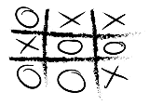  Outdoor Maths  You will need:  https://playofthewild.com/2020/08/19/outdoor-maths-activities-ks1-maths-outdoor-learning/  https://creativestarlearning.co.uk/maths-outdoors/  Slide 15 – page 9 25 Outdoor activities Creative Star | https://www.natgeokids.com/uk/primary-resource/shapes-primary-resource/
https://www.bbc.co.uk/teach/school-radio/audio-maths-rainbow-quiz/zhdvpg8

In addition to these ideas/examples you can use last years’ resources if the children didn’t access them at home.
I also have a folder of problem solving work which is in my office and welcome to use.

