 **EDUCATION & CHILDREN’S SERVICES**

STANDARDS & QUALITY REPORT

**2015-16**



**LAST UPDATED: September 2016**



**Insch School**

Alexander Street

Insch

AB52 6JH

[Phone](https://www.google.co.uk/search?safe=strict&espv=2&biw=1366&bih=628&q=insch+primary+school+phone&stick=H4sIAAAAAAAAAOPgE-LSz9U3yIs3rzIo1NLPTrbST87PyUlNLsnMz9PPzssvz0lNSU-NL0jMS80p1s9ILI4vyMjPS7UCkwA3VVqlPwAAAA&sa=X&ved=0ahUKEwiB5_Wt4-nOAhVZFMAKHVIiCFIQ6BMIiwEwFA): 01464 820252

**Email**: insch.sch@aberdeenshire.gov.uk

**Website:** [www.insch.aberdeenshire.co.uk](http://www.insch.aberdeenshire.co.uk)

**Aberdeenshire Council Education & Children’s Services**

“Education & Children’s Services works to improve the lives of children and young people, families and communities through the delivery of high quality services across Aberdeenshire”

|  |
| --- |
| **The School in Context** |

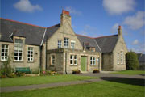

Insch School is a large, rural primary school situated in the village of Insch in Aberdeenshire. The school serves a catchment area that is socially and economically diverse. We presently have 297 P1 -7 pupils and 120 nursery pupils. The school is part of the Huntly schools cluster and pupils transfer to The Gordon Schools, Huntly and Inverurie Academy. There are currently 12 classes and four nursery classes. Our school is led by a relatively new SLT (Mrs Conner, Head Teacher and 2 Deputes, Miss Catlow and Mrs Stirling) and 14 committed class teachers, many of whom are recently qualified. The team are supported by a full time SFL teacher and nurture team who work with a few pupils with high tariff support needs. Our team of 10 part time Pupil Support Assistants support the staff and pupils throughout. Our visiting specialist teachers deliver Music, PE and Art. Our Nursery team comprises our Depute, Mrs Stirling, 2 Early Years Practitioners, 4 Early Years Practitioners and a newly appointed Cluster based Early Years Principal Teacher. The effective running of the school is supported by an Administrator, Clerical Assistant, Janitor and 2 cleaners. This team have worked since August 2014 to lead change and improvement throughout the school and nursery. Children engage in the life of the school through the wide range of lunch time and after school clubs that are offered by school staff allowing pupils to achieve out with the classroom as well as within. The school benefits greatly from a strong and purposeful parental involvement through the Parent Council, PTA and parent volunteers. We aim to be an inclusive school through our nurturing, dyslexic and ASD friendly approaches.

|  |
| --- |
| **Key Developmpent - Progress during 2015/16**  ***What have we achieved?*** |
| **Vision, Values and Aims (VVAs)**   * New school vision, values and aims finalised. * Child friendly set of behaviour values created. * Values are now embedded acorss the school and pupils know these values well. * School uniform project completed with staff, pupil, parent and community consultation. New school logo reflects the new VVAs. * Golden Table and Termly Head Teachers awards reinforce school values and the 4 capacities. * Pupil Playground Circle led a thorough Evaluation exercise of what the School Playground offered and looked at how it could be improved for our pupils. £10K Awards for All Grant awarded for some of the new equpiment. Very successful playground fundraising event raised a further £3k. * Parents, pupils and Miss Catlow created new playground in Summer holidays, ready for start of session 2016-17. |
| **Meeting Learner Needs**   * Literacy Toolkits established in all classes. Staff now have a framework to follow to support pupils with literacy difficulties. * ASN Support Station packs established in all classes. These support Authority Austistic Friendly framework. * Nurture space created – The Zone, Sensory areas. * Staff training completed: Read & Write Gold, 2 Simple software, nurtuirng approaches, Epilepsy, CALMS. * Relaxation training delivered (Relax Kids) and relaxation techniques part of daily class routine. * Insch KM Club – Whole school run 1km every day. Increased concentration in class at periods of the day when pupil focus normal dip. * Widgits Communication symbols – used by staff across school to aid communication. * Literacy Leaders established to share liteacy support strageies. This is led by pupils for pupils |
| **Effective Learning and Teaching**   * Culture of Leadership of learning by staff established. Areas of study covering aspects of Learning and Teaching. Effective Learning and teaching booklet created for staff by staff. * Staff training: Numicon Maths, Number Talks. * Culture of whole school evaluation e.g. Learning Circles – Management team meet regularly with pupils to discuss aspects of learning: ICT, Maths, Reading. These discussions have led to improvements e.g. review of Digital Technologies. * Digital Technology – investment in ipads gives us 8 ipads for 4 older classes. Digital Leaders (pupils) trained and share expertise with whole school. Further investment to follow. |
| **The Curriculum**   * Curricular Rationale created and shared with staff and parents. * Coverage of Curriculum Experiences and Outcomes organised into Bundles to ensure coverage and progression across the school. * Authority Curriculum frameworks for Literacy, Numeracy and Health & Wellbeing in place for staff. This ensures progression throguh the CfE levels and assists teacher assessment. * Sexual Health plans reviewed, updated and implimented. Shared with parents. * Rigorous tracking of attainment across school in Numeracy, Literacy and H&WB. We have embedded a Tracking Monitoring and Reporting system (TMR) across the school. This allows progress of individual pupils to be tracked. Senior Management Team liaise closely with teachers to monitor and plan next steps for individual pupils based on data. |

|  |
| --- |
| **Whole School Evaluation of Session 2015-16** |

**Key**

**Evaluation – Excellent** -outstanding, sector-leading **very good** - major strengths **Good** - important strengths with some areas for improvement **Satisfactory** - strengths just outweigh weaknesses **Weak** - important weaknesses **Unsatisfactory -** major weaknesses

|  |  |  |
| --- | --- | --- |
| 1. **How good is our leadership and approach to improvement?**   **QI 1.1** Self-evaluation for self-improvement  **QI 1.2** Leadership of learning | | |
| **QI 1.1** Self-evaluation for self-improvement |  | 3 |
| **QI 1.2** Leadership of learning |  | 3 |
|  | | |
| **In arriving at these evaluations, we considered the following evidence.** | | |
|  | | |
| * Parent, Staff and Pupil Pre Inspection questionnaires, polls, monthly parent postcards, Nursery Together Tuesday evaluations. * Quality Assurance Calendar, Self-Evaluation Calendar, SIP annual review, TMR data. | | |
| **Our key strengths in this area are** | | |
| * As a result of the intense work carried out this year to re-launch the schools vision, values and aims almost all learners and staff understand and support the schools values: Aiming High, Being Safe, Showing Respect and Valuing our Community. * Our parents tell us daily that they are happy with the strong ethos of implementing change. They tell us they have seen a big difference in the school over the past year and a half. * Our teachers are leading many of the school’s improvements. Digital Leaders, Literacy Leaders, Outdoor Learning, Cooking and Science development work. This work has led to increased leadership opportunities for young learners as well. This approach has led to positive change. * Following our recent Care Commission Inspection nursery staff have worked in a positive collegiate way to implement improvements. These include further improving medical protocol and creating clearly defined safe learning spaces. * We have a rigorous self-evaluation calendar. We take steps to involve our stakeholders in nursery and in school. We engage with our pupils and parents regularly in a variety of ways. We use this information to help inform our next steps in improvements. Most feedback is constructive and we act quickly to bring about required change. (Learning Circles, Together Tuesdays, Parent Forums, Parent Postcards, Parent evaluations, Staff evaluation exercises, questions at school events, P1 Focus Group). * Our new and rigorous TMR system shows us that pupil attainment has increased. Comparing attainment figures from Nov 2015 to Nov 2014 when we started the process, figures have increased overall in all areas. * We now track attainment 3 times a year, have follow up professional discussions and plan interventions for specific learners. * Flexible curriculum opportunities and the tracking of wider achievement has greatly improved the self-esteem of our ASN pupils and the data we collect is used to plan interventions. | | |
| **We have identified the following as priorities for improvement in this area** | | |
|  | | |
| * Further develop Moderation activities both in school and Cluster based to further develop validity and reliability of CfE levels. * Continue to build on rate of change established this year. Follow through on changes started this year ensuring impact e.g. Assessment, Moderation, by protecting time for professional dialogue, collegiate learning and self-evaluation. * Continue to work across the school embedding behaviour expectations through planned Bounce back and resilience work. Set up Behaviour Policy with parent, pupil and staff consultation. * Create a free flow nursery experience across both nursery locations and implement the Key Worker System in August 2016, introduce nursery friendly values/behaviours/expectation and embed this across nursery. | | |

|  |  |  |
| --- | --- | --- |
| 1. **How good is quality of the care and education we offer?**   QI 2.2 Curriculum  QI 2.3 Learning, Teaching and Assessment | | |
| QI 2.2 Curriculum |  | 3 |
| QI 2.3 Learning Teaching & Assessment |  | 3 |
|  | | |
| **In arriving at these evaluations, we considered the following evidence.** | | |
|  | | |
| * Curriculum Rationale, Curriculum Frameworks and Benchmarks, CfE Bundling, School Review and Partner agency work. * Pupil input from planning sessions: KWL grids/ Big Book Planning/ Talking Tubs in nursery. * Use of our unique setting to enhance learning and teaching experiences – The Meadows, Dunnydeer, our Community links. | | |
| **Our key strengths in this area are:** | | |
| * Our curriculum has a clear vision and rationale that is shared. * Teachers’ planning indicates appropriate differentiation to meet the needs of learners. Our planning is flexible and highly responsive. Almost all pupils are making significant progress in their learning as a result of our flexible curriculum approaches. * Practitioners in nursery and in the school seek the views of our learners ensuring personalisation and choice through the use of KWL grids, Big Book Planning Talking Tubs and other methods. * Good use of our unique setting is made to enrich learning: Meadows, school playground, community groups, school garden, outdoor learning (P6), Forest Owls. * We have recently refreshed the curriculum and have reintroduced the 4 capacities to be integral to curriculum experiences offered. The curriculum has been organized into Curriculum Bundles ensuring appropriate coverage of Experiences and Outcomes and links to RRS and Eco school. * Our nursery team work well together providing innovative and creative opportunities for children. Almost all our parents tell us that their children love to come to nursery. Children are happy and engaged in the learning that takes place e.g. outdoor mud kitchen. * We have established strong partnerships with partner agencies. All our partner planning meetings show that we adapt and find creative ways to meet the needs of individuals and learning is enriched. * Learning Technologies - We reviewed provision, formed an action plan and delivered quality CPD for staff. The work was led by 2 class teachers. Through fundraising and school budget we have increased the technology kit in use across the school. * There are opportunities for pupil’s to lead learning: Playground Circle, Digital Leaders, Literacy Leaders, Pupil Council. Our weekly Golden Table shows us that learners are successful in developing the skills of the 4 capacities. * We use Creative approaches to engage our families in their child’s learning. Our Curricular Evening ‘Strategies to Support All’ told us that they found it useful to find out how their children were supported in maths, literacy, mindfulness and technology. They told us this helped them support their children with home learning. Parents tell us they understand and see the benefits of the Insch KM club in increasing health and wellbeing and increasing concentration levels back in class. * We have developed transition arrangements that focus on ensuring a high level of social and emotional support for our pupils. Parents tell us the summer holiday teacher postcards helped their child settle more quickly to their new class. * We have developed strong links with the community (ICAN, Museum, Lunch Club, Hospital, Library, BLC, Day Care Centre). These have enabled us to provide creative learning opportunities out with school and impact positively on learners. We work closely with our PC and PTA and we support each other well e.g. School Uniform community consultation, fundraising events (Technology), Playground Fundraiser, Carols by Candlelight Christmas event. | | |
| **We have identified the following as priorities for improvement in this area** | | |
|  | | |
| * Continue work on assessment and further develop teacher confidence to ensure assessment evidence is valid and reliable. * Implement the new Reporting to Parents calendar this coming year. This will inform parents more effectively of learner’s progress throughout the year. | | |

|  |  |  |
| --- | --- | --- |
| 1. **How good are we at ensuring the best possible outcome for our learners?**   QI 3.1 Improving wellbeing, equality & inclusion.  QI 3.2 Raising attainment & achievement. | | |
|  | **Evaluation** | |
| **QI** 3.1 Improving wellbeing, equality & inclusion. |  | 3 |
| **QI** 3.2 Raising attainment & achievement. |  | 3 |
|  | | |
| **In arriving at these evaluations, we considered the following evidence.** | | |
|  | | |
| * P4-7 SHANARRI questionnaire, review meetings, Literacy toolkit checklists, TMR Data, EPips, Incas data and follow up SLT and staff professional discussions, timetables, flexible curriculum. | | |
| **Our key strengths in this area are** | | |
| * Our P4-7 pupils tell us they feel healthy, achieving, nurtured, active, respected, and responsible and included. We know this because we asked them using a questionnaire. * Almost all our pupils are achieving because of our approach to delivering equity of provision. Our dyslexic and ASD approaches are delivering impact on learners e.g. literacy toolkits, ASD toolkits, relaxation sessions, Toe by Toe, motor skills, Sensory areas and memory skills. * We have a robust system that tracks individual and class attainment and achievement. We can compare our Incas results in P3, P5, P7 with that of the Cluster and Authority. | | |
| **We have identified the following as priorities for improvement in this area** | | |
|  | | |
| * Be more systemic about celebrating achievement at assembly e.g. Celebrating Stars session at assembly. * Develop a method to share pupil progress with parents more regularly and inform parents how they can support pupils in learning at home. * Continue to evaluate attainment data. Work collaboratively with stage partners and SLT across the school. Compare teacher judgment data with Incas and Epips data. Ensure progress is in line with pupil ability and support and challenge appropriately. Continue focus on raising attainment in Literacy, Numeracy and H&WB. | | |

|  |
| --- |
| **Highlights of 2015-16** |

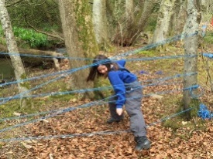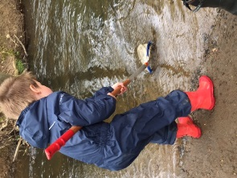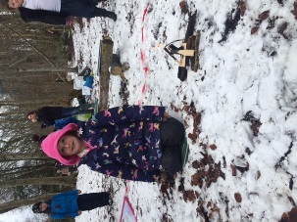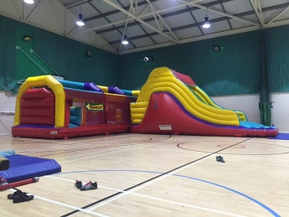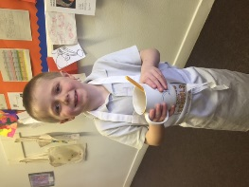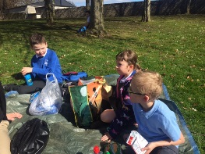

Flexible curriculum opportunities, including Forest Owls, cooking, snack time after swimming and BLC sessions.

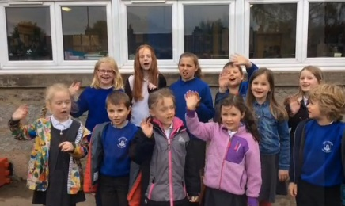 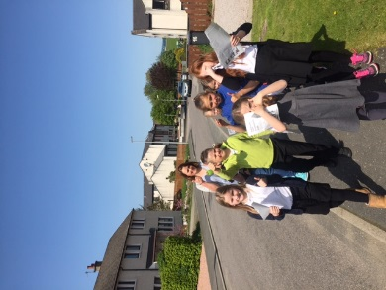 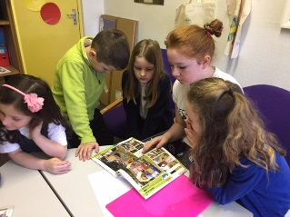

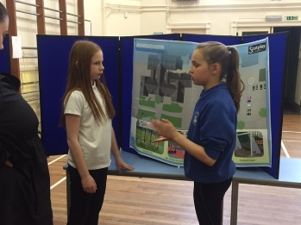 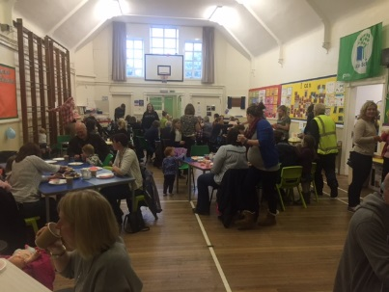 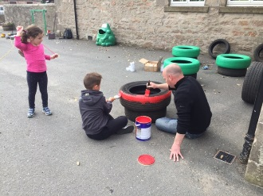 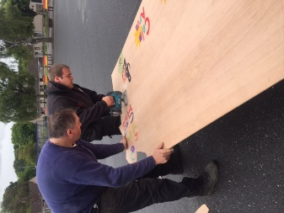

Playground Development (left to right, top to bottom);

Playground Leaders, playground leaders delivering flyers to the community, playground leaders choosing new equipment, sharing the developments at Parents Evenings, Community Café fundraiser, painting bug tyres and cutting up new signs with Parent Volunteers.

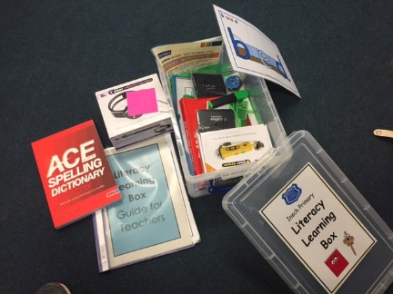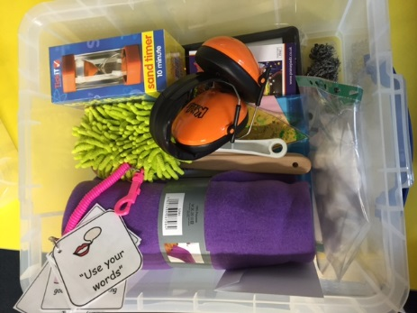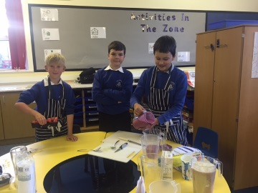A very successful Smoothie Business run by a group of our P6 and P7 pupils.

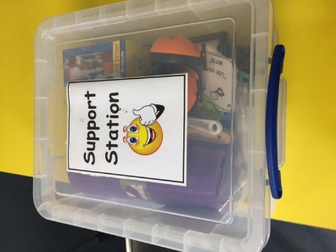 Support Stations and Literacy Learning boxes have been set up in every classroom to support learning and teaching.

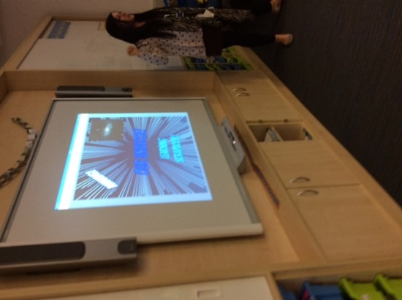 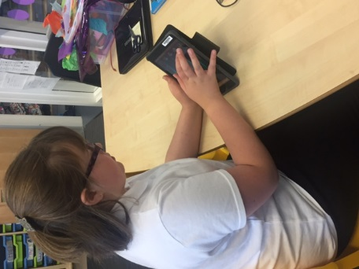 New technologies were shared with our parents during our Parent Partnership ‘Strategies to Support All’ evening. One of our P7 pupils using the iPad to enhance her learning.

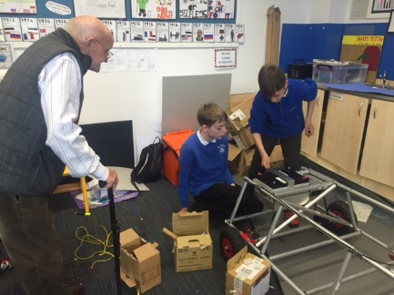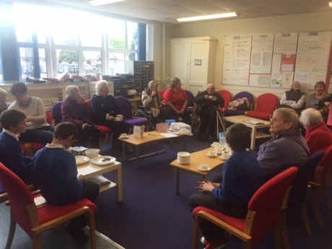

Links with the Community: A visit from the Day Care Centre. The P7s shared their kit car project confidently. They won ‘best scrapbook’ at the kit car competition.

|  |
| --- |
| **Looking Forward - Summary of Improvement Priorities 2016-17** |

|  |
| --- |
| **Reporting to Parents** |
| *Parents will be more informed of their child’s learning, how they progressing and how they can support their child at home.*  We will develop an improved process of reporting learner’s progress and achievement to parents.  This will include:-   * a reporting to parents calendar with events identified where parents will be invited into school to see what children’s learning in action. * a revised end of year formal report. * a tool to share learning regularly with parents so they know what their child is learning, how they progressing and how they can support at home. |
| **Quality Learning, Teaching & Assessment** |
| *We aim to have consistency across the school in key aspects of high quality learning and teaching.*  In particular, we will be developing across the whole school:   * Resilience program across the school ‘Bounce Back’.   *Our pupils will be able to bounce back from tricky situations and have strategies to do this confidently.*   * Cognitive Skills training   *Skills pupils are developing will be central to teacher planning.*   * Quality Questioning   *Pupils learning will be deepened by use of effective adult questioning*   * Reflective Language   *Pupils will be able to talk confidently about their learning, where they are, what skills they are developing and how they can improve further.*   * Moderation   *Staff will have a shared understanding of curriculum levels.*  *There will be greater consistency of high quality of learning and teaching across the school.*   * AiFL Techniques (Assessment is for Learning techniques)   *Pupils will have a greater understanding of how they are progressing in learning and what they need to do to improve.*   * Digital Technologies   *Technology will be used in many classes to enhance learning and teaching.* |
| **The Curriculum** |
| This year particular focus will be on developing teacher skills in the teaching of Science and 1 +2 languages. This will achieved through Cluster staff collegiate training. Literacy boxes will be continued to be used to support pupils. |
| **Behaviour** |
| There will be joint working with parents, staff and pupils to revise and review our behaviour Policy.  The impact of the new playground installed over the summer will be reviewed and evaluated by staff and pupils. |
| **Nursery Class** |
| * **Key Worker System** (KWS) – A KWS will be implemented ensuring continuity and progression of a child’s health, wellbeing and development. * **Free Flow Nursery** – To redesign the nursery setting to allow for a free flow nursery experience between the rooms and outdoor play area. * **Quality of learning experiences** **and adult interactions** – In line with whole school, to further develop quality of learning experience and adult interactions using Building the Ambition material and quality questioning. |